Restorative Approaches Leaflet
for
Parents and Pupils

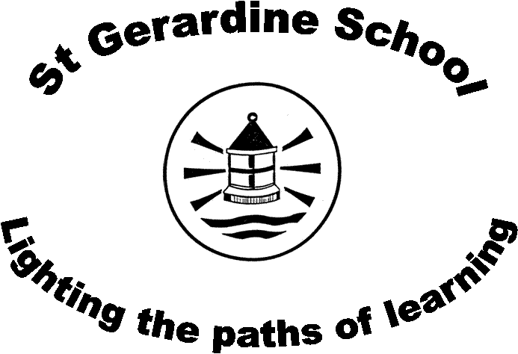

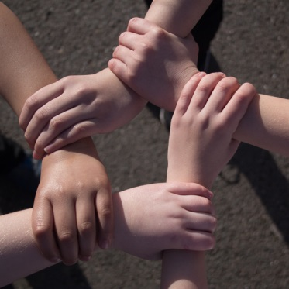
St Gerardine School

What is a “Restorative Approach”?
A restorative school is one which takes a restorative approach to resolving conflict and preventing harm. Restorative approaches enable those who have been harmed/hurt to convey the impact of the harm/hurt to those responsible, and for those responsible to acknowledge this impact and take steps to put it right.

Why Use a Restorative Approach?
When there is conflict or there are problems in school between children or between children and adults, a restorative approach has been shown to be more effective than simply giving a punishment. Research shows that restorative approaches help schools create peaceful learning environments for children to become successful learners, confident individuals, responsible citizens and effective contributors.
Children who have shown inappropriate behaviour or who have fallen out with someone will be encouraged to take responsibility for their actions and to think how they can improve their behaviour in the future.

This allows the school to:
- help children who have been upset by ensuring the wrongdoer has the opportunity to put right the upset they have caused
- help children showing inappropriate behaviour to reflect, make amends and take responsibility for the way they have behaved
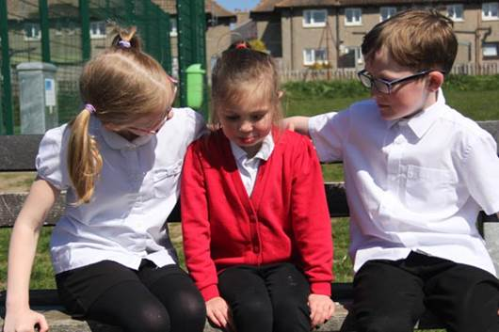

Often a restorative meeting will take place. At the meeting, the person leading the meeting will encourage a restorative conversation between those involved.
What does a Restorative Meeting Look Like?
The person leading the meeting may ask the following questions:
- Can you tell me what happened?
  - each person will have an opportunity to say what happened
  - the person leading the meeting will then summarise what has been said to check understanding of events

- What were you thinking/feeling at the time?
  - some children may need support initially to express their thoughts/feelings and the person leading the meeting can offer prompts (sad/angry/worried/frustrated/upset/annoyed etc.) or other questions (eg. what was going on in your head when you did that?)

- How do you feel now about what happened?
  - again, the person leading the meeting can support children with prompts

- Who else has been affected by this? How have they been affected?
  - (eg. other children, other adults in school, family etc.)

- What needs to happen now to make things better/improve the situation/help you move on? What do you need to do?
  - it is important for the children involved to acknowledge the harm/hurt to others
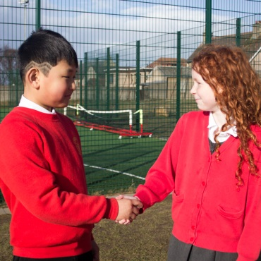
  - children may apologise
  - they may agree consequences for their behaviour or actions to make things better in the future

- Summary and follow-up
  - the person leading the meeting will go over what has been agreed
  - the children or the adult leading the meeting will agree on any follow-up plan (eg. checking that relationships have improved etc.)
Sometimes when children have been involved in conflict or are very upset or angry about what has happened, they are not ready to hold a restorative meeting straight away. However, usually children are ready later in the day or the next day and they are generally quite clear themselves about when they are ready.


At St Gerardine, all staff have been trained in restorative approaches and are encouraged to use this approach to resolve conflict and sort out problems which may arise.

Further Information about Restorative Approaches

- Education Scotland Parentzone website:
https://education.gov.scot/parentzone/additional-support/specific-support-needs/social-and-emotional-factors/Restorative%20approaches

- Restorative Justice in Scotland’s Schools: http://www.restorativejusticescotland.org.uk/html/schools.html
