Anti-Bullying Leaflet
for
Parents



St Gerardine School
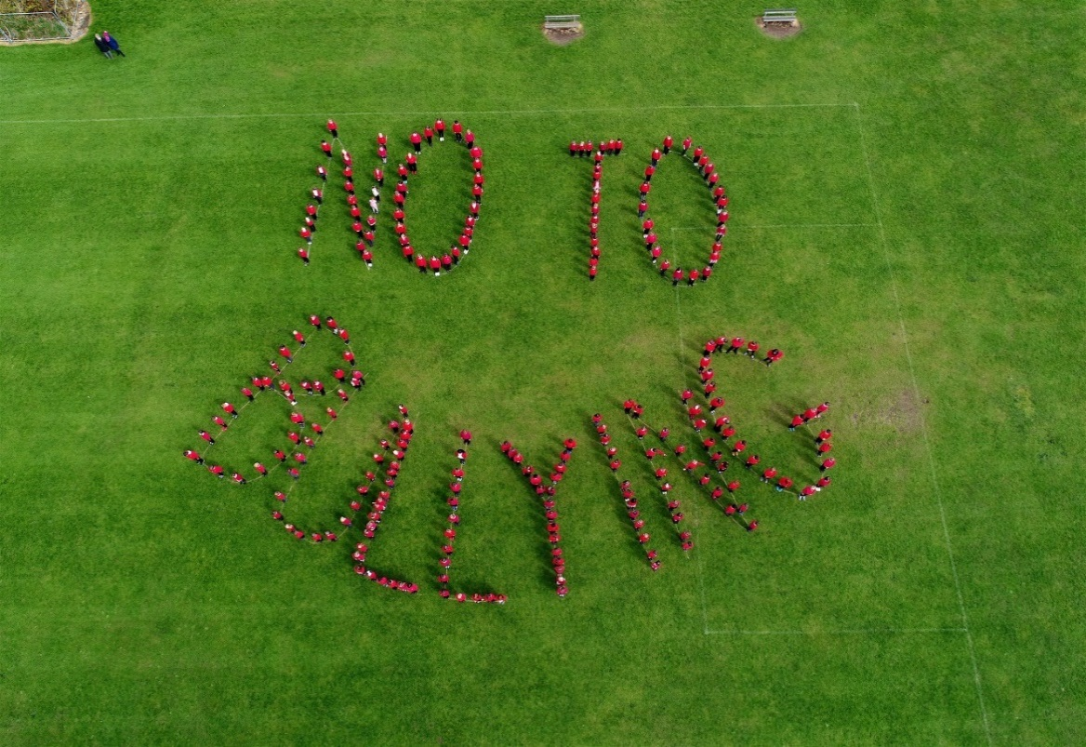

Our aims at St Gerardine
We aim to:

- promote a caring and supportive ethos in our school
- create an environment and code of behaviour where bullying is completely unacceptable
- create a safe environment in which pupils can confidently report bullying to an adult
- deal effectively with reported incidents and give appropriate support to pupils
- make clear to the whole school community that bullying, in any form, will not be tolerated
- tackle bullying by working in close partnership with parents and pupils

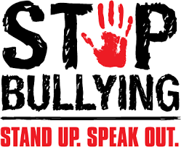

What is bullying?

Bullying is the wilful, conscious desire to hurt, frighten or threaten someone. It is a pattern of deliberately hurtful behaviour. It is usually repeated over a period of time.

It involves an imbalance of power, a dominance of one person over another. It can lead to feelings of fear, worthlessness and depression and can have lasting effects.

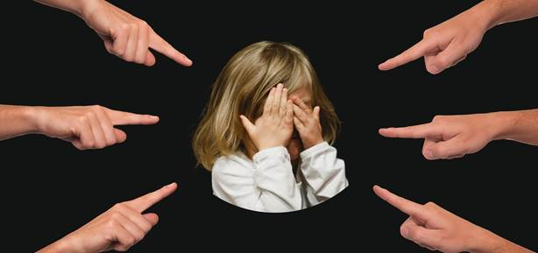

Bullying is not a one-off incident of name-calling, arguing or fighting. It should be distinguished from normal child-like behaviour and the ‘one-off’ incidents that sometimes occur between children as they are growing up and learning social skills.
What are the different types of bullying?
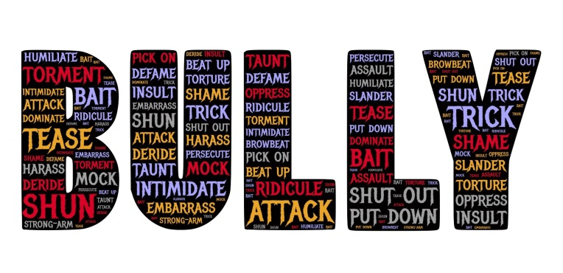

Bullying may take a variety of forms, including the following:

Physical bullying: hitting, kicking, pushing, grabbing and damaging, taking or hiding someone’s belongings.

Verbal bullying: name calling, swearing, threats, making fun/ teasing.

Emotional/psychological bullying: leaving someone out, spreading rumours, refusing to talk to someone, whispering, staring, intimidating, gesturing.

Prejudice-based bullying: racism, sexism, homophobia or picking on a disability
These may relate to any perceived or actual differences which makes vulnerable children particularly at risk.

Cyber-bullying: tormenting, threatening, harassing, humiliating, embarrassing or otherwise targeting another child using the internet, interactive and digital technologies or mobile phones.
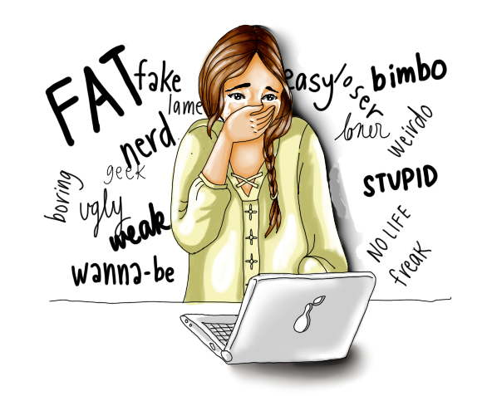
Why do children bully?

Children bully for many reasons, including the following:

- they may be unhappy or going through a difficult time
- to make themselves more popular
- to gain a sense of power or control

- pressure from friends

Bullies must not be allowed to continue behaving in this way, but they may also need help to change.

What are the signs that a child may be being bullied?

If you think your child may be being bullied, the following are some possible signs to watch out for (although there are many other possible explanations for these signs as well):

- being frightened to walk to or from school
- not wanting to go to school
- feeling ill at certain times of the week
- becoming withdrawn or anxious
- changes in their usual behaviour
- crying in secret or crying themselves to sleep
- having nightmares or interrupted sleep
- bedwetting
- beginning to do poorly in schoolwork
- becoming disruptive, aggressive or unreasonable
- coming home regularly physically hurt or with damaged clothes or possessions
What will the school do?
When an alleged bullying incident is raised, the school will take the following course of action:
- the allegations will be investigated through discussion with the relevant children and any appropriate members of staff/adults
- where bullying is suspected or confirmed, a record will be filed in the Bullying File in the Head Teacher’s office
- staff will make it clear to the pupil(s) involved that bullying behaviour is unacceptable
- outcomes will be agreed with those involved to resolve the incident
- the school will monitor and record any further developments and follow-up over a period of time
- where a bullying incident is confirmed, the parents of both victim and perpetrator will be contacted
General strategies used by the school to tackle bullying:

A combination of strategies are used in school to reduce incidents of bullying including:

- regular class discussions eg. circle time to talk about playground behaviour or other friendship issues concerning the children
- reminders of our school values, class/school rules and what is acceptable behaviour
- celebration of achievements in assemblies where positive behaviours are recognised
- teaching children not to tolerate bullying and know who to speak with if worried
- helping children to develop positive strategies and to assert themselves
- teaching children about keeping themselves safe when using the computer and other technologies
What can parents/carers do if your child is being bullied?

- reassure your child that they have done the right thing in telling
- talk calmly with your child and listen to what they say
- explain to your child that they must report any further incidents to you or the school
- inform the school immediately and/or ask for an appointment to see a member of staff
- do not confront other children or their parents

It is crucial for parents to monitor your child’s use of chatrooms or instant messaging systems. If your child does receive inappropriate, nasty or threatening messages from another child at St Gerardine, please inform the school straight away.

What can parents/carers do if your child is bullying another child?

- listen to your child’s explanation
- explain why their behaviour is unacceptable
- praise and encourage positive behaviour
- keep talking to your child
- spend positive time with your child, one-to-one if possible
- talk regularly to your child’s teacher about their behaviour

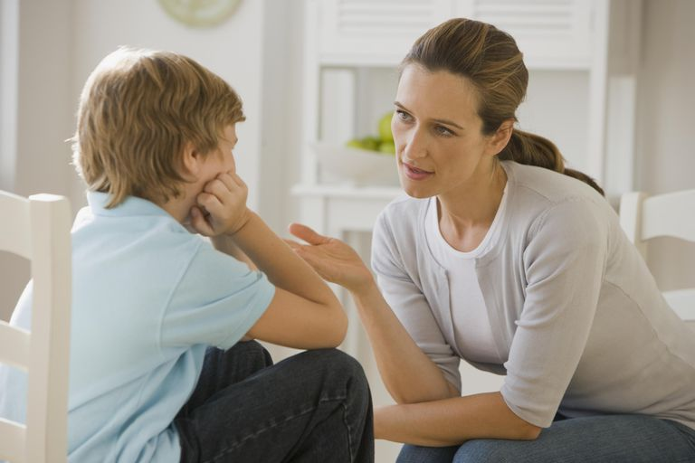

What can pupils do?

If you are being bullied:

- DO tell an adult in the school
- DO tell your family
- DO keep telling people until you feel safe
- DO take a friend with you to report bullying if you want to
- DON’T blame yourself for what is happening


If you think someone else is being bullied:

- DO let an adult know
- DO try and be a friend to the person being bullied
- DON’T rush over and take the bully on
- DON’T join in
Further information and advice

Below is a list of helplines and websites which can offer valuable support to parents and children:

Scotland’s Anti-Bullying Service
0844 800 8600 www.respectme.org.uk

Childline
0800 1111 www.childline.org.uk

Kidscape
0845 120 5204 www.kidscape.org.uk

Parentlineplus
0808 800 2222 www.bullying.co.uk

