Home School Link Worker Weekly Bulletin 14.03.24

Welcome back to our weekly bulletin! We hope you will find this bulletin useful and informative. Each week we aim to include some tips and advice to support your family at home, news and reminders of local and national events that may be of interest and links to other services and agencies that may provide support.

Sleep


March 15th is World Sleep Day. Sleep is really important for everyone but bedtimes can be difficult for lots of different reasons. Lots of young children find it difficult to settle down to sleep and will wake up during the night. For some people, this might not be a problem. But if you or your child are suffering from a lack of sleep, there are some simple things you can try. Every child is different, so only do what you feel comfortable with and what you think will suit your child. If your child will not go to bed:
- Decide what time you want your child to go to bed.
- Start a "winding down" bedtime routine around 30 minutes before the time that your child usually falls asleep. Bring this forward by 5 to 10 minutes each week – or 15 minutes if your child is in the habit of going to bed very late – until you get to the bedtime you want.
- Set a limit on how much time you spend with your child when you put them to bed. For example, read only 1 story, then tuck your child in and say goodnight.
- Give your child their favourite toy, dummy (if they use one) or comforter before settling into bed.
- Leave a dim light on if necessary.
- If your child gets up, keep taking them back to bed again with as little fuss as possible.
- Try to be consistent.
- You may have to repeat this routine for several nights.

Sleep tips for under-5s
- Make sure you have a calming, predictable bedtime routine that happens at the same time and includes the same things every night.
- If your child complains that they're hungry at night, try giving them a bowl of cereal and milk before bed (make sure you brush their teeth afterwards).
- If your child is afraid of the dark, consider using a nightlight or leaving a landing light on.
- Do not let your child look at laptops, tablets or phones in the 30 to 60 minutes before bed – the light from screens can interfere with sleep.
- If your child wakes up during the night, be as boring as possible to avoid exciting them and leave lights off.
- Avoid long naps in the afternoon.

Fun activity of the week:
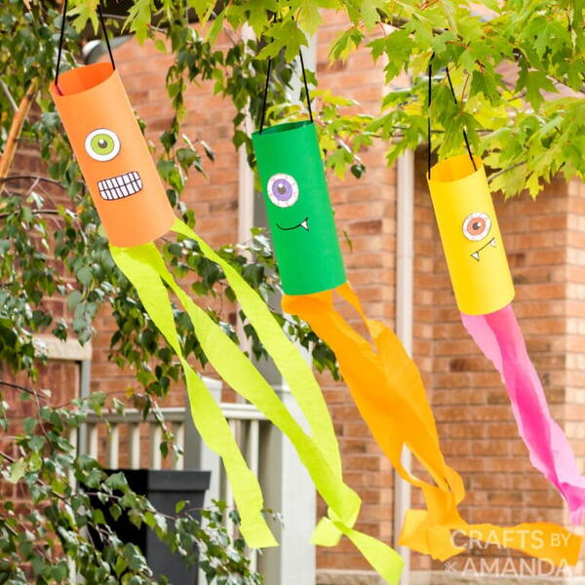
Garden Wind Sock

Get yourself a piece of card and decorate it to make the face for your windsock. Then, roll your card into a tube shape and stick together with tape. Attach some string to the top of your tube with tape to make the handle. Cut out strips of paper, ribbon, wool or whatever you like, to create streamers and attach these to the bottom of your tube.
Then you can then hang up your windsock in a tree and sit back and watch the streamers
blow in the spring breeze!

Recipe of the week:

Recipe of the week: Honey chicken

Ingredients:
• 4 chicken breasts (about 600g), trimmed and cut into 2-
3cm cubes
• 2 tbsp plain flour
• 40g piece of ginger, peeled and finely grated
• 4 garlic cloves, finely chopped
• 6 tbsp soy sauce
• 5 tbsp honey
• ½-1 lemon, juiced
• 1 tbsp sunflower, vegetable, rice bran or rapeseed oil
• cooked rice and steamed broccoli, to serve (optional)
Method:
1. Tip the chicken into a bowl, sprinkle over the flour and some seasoning and toss until the
chicken is evenly coated.
2. Combine the ginger, garlic, soy, honey and half the lemon juice in a bowl.
3. Heat the oil in a large frying pan or wok over a high heat and fry the chicken for 3-4 mins
until lightly golden.
4. Tip in the honey sauce and stir-fry for 10 mins, or until the chicken is cooked through and
the sauce has reduced enough to coat the back of a spoon.
5. Taste for seasoning and squeeze over the remaining lemon juice, if needed, then serve with rice and steamed broccoli, if you like.

Get in touch
If you would like any further help, guidance or support for you or your family, please contact Derri Chamberlain (Home School Link Worker)
Derri.Chamberlain@moray-edunet.gov.uk
(Working hours: Monday – Thursday 8.00am-4.00pm and Friday 8.00am - 3:00pm).
-----------------------------------------------------------------------------------------------------------

